Session Diagrams
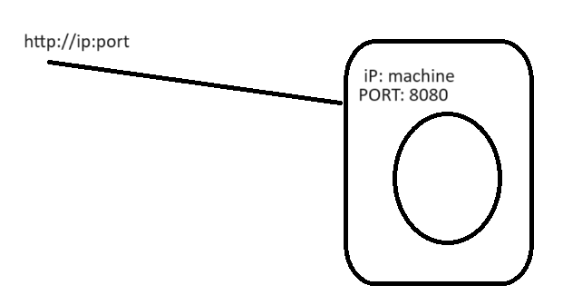
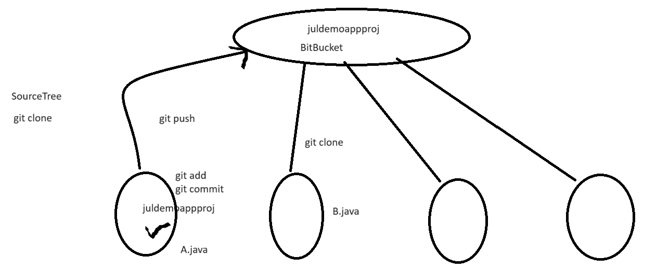
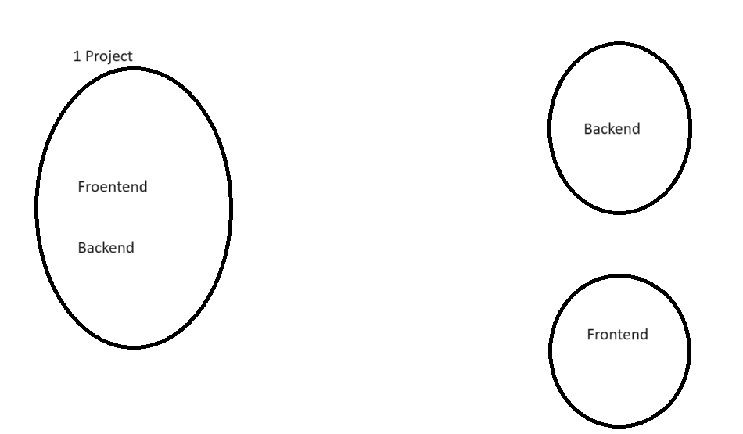

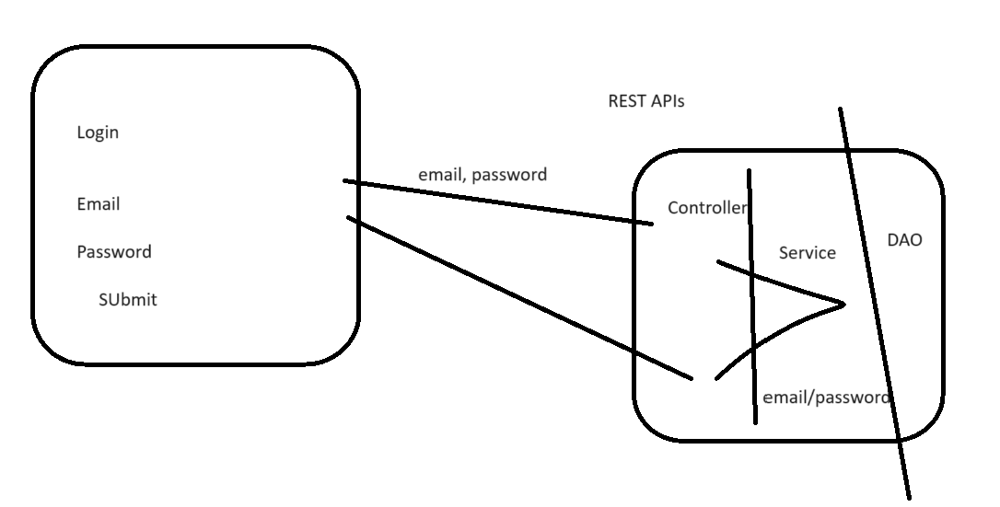

LIVE Session Notes
Day3 - End-to-end working in IT, Part3

=> Working with Version Control - Git / BitBucket
=> Project Coding Standards
=> Writing Controller & RestAPI
=> Log4J & working with Logging
=> Agile
=> Etc..

Webapplication using SpringBoot

1. 1st Spring Boot application
start.spring.io
2. IDE - Eclipse STS
3. Maven (Build Tool)

You have project in IDE.
You are not supposed to code on this project.

Coding project
Complile & Build - mvn clean package
Execute - Server
- java -jar <file>.jar

How to execute Spring Boot application
mvn clean package
java -jar <file>.jar

2. Directly from IDE
Maven:
clean spring-boot:run

2 services cannot occupy same port.

Start with Code

JulDemoApp

4 Java Developers
=> Only 1 person will create this project structure. Maven dependencies.. and share this project with everyone.

D1: YOU
A.java

D2: Me
B.java

Project
A.java
B.java

Deploy to PROD

When multiple developers are working.. then close coordination of code is required..

Tool / process

Version Control System.

GIT
GitHub, GitLab, BitBucket - platforms where we can keep git related projects.

If you are working only in your local machine.. having only GIT installed is OK.

But when you work with team.. you would need to use GitPlatform (GitHub, GitLab, BitBucket)
Cloud

1. Place our project into BitBucket

Maven Project

Git repository

https://bitbucket.org
1. Create Project
2. Create repository

Client data cannot be publicly shared..

The code from local IDE, we need to place inside cloud Bitbucket.
=>
1. Create a local sync folder
clone (SourceTree)

2. Add code in local sync folder
from the maven project in your local machine.
Copy all files/folders, and place it in your local sync folder.
exclude target folder & .settings.

3. Move code from local to cloud location
git add
git commit

git push

We want to do code changes...

IN which folder, I should make code changes?
2 folder:
1 In IDE project
2 in sync folder.

Git Commands also
git clone
git add
git status
git push
git commit

CLI - GUI

SourceTree https://www.sourcetreeapp.com/

We always work upon project which is kept in Git / Bitbucket

Get the project from the sync folder, into your IDE, and start coding on that.

Agile
Jira
Spring Boot (star.spring.io)
IDE Eclipse
Maven Build tool
Git, SOurceTree
RestCOntroller ChatGPT
CURL
POstMan

Distributed APplication (software - software)

1. Dont code both frontend & backend together in same project.
Rather have separate projects for both.
2. Backend needs to write & expose RestAPIs, which fe would be invoking.

3. Layered Application
Controller - routing logic, basic validation
Service - Business logic
DAO / Repository - Database logic

4. How to write Rest Controller in SpringBoot application.
add - takes 2 integers, and resturns the sum in response.

API:

Endpoint:
http://localhost:8080/add
Request:
?num1=10&num2=20
Response

Browser:
http://localhost:8080/add?num1=10&num2=20

curl "http://localhost:8080/add?num1=10&num2=20"

https://www.postman.com/downloads/

For accessing a service, we need which machine(iP) & what port.

localhost (your current machine)

http://localhost:8080

<protocol>://<ip>:<port>
src/main/resources/static/index.html

Webapplication/// webapplication - http

Tomcat is default embedded server for SpringBoot Application.

Start with Coding.

